Phishing Website Detection using Hybrid and Machine Learning Techniques.
Manoj V
School of Engineering,

Chanakya University
ABSTRACT
Phishing attacks are one of the most common cybersecurity threats, where attackers create fraudulent websites to steal sensitive user information such as login credentials and financial data. Traditional detection techniques such as blacklist-based approaches are ineffective in identifying newly generated phishing websites. This paper presents a machine learning-based approach for phishing website detection. The study is based on an existing research work that proposes a hybrid model using K-Nearest Neighbors (KNN) and Support Vector Machine (SVM). In this work, we extend the approach by implementing KNN and Logistic Regression models and evaluating their performance. Experimental results show that KNN achieves an accuracy of 93.98%, while Logistic Regression achieves 93.35%, demonstrating the effectiveness of machine learning techniques in phishing detection.

KEYWORDS
Phishing, Machine Learning, KNN, Logistic Regression, Cybersecurity.

1. INTRODUCTION
Phishing is a type of cyber-attack in which attackers create fake websites that closely resemble legitimate websites to deceive users into revealing sensitive information such as usernames, passwords, and credit card details. With the rapid growth of internet usage, phishing attacks have become increasingly sophisticated and difficult to detect.
Traditional methods such as blacklist-based detection and heuristic techniques are not effective in identifying newly created phishing websites, also known as zero-day attacks. Therefore, machine learning techniques have gained significant attention in cybersecurity for detecting phishing websites based on patterns and features extracted from data.
This paper focuses on applying machine learning algorithms to detect phishing websites and evaluating their performance.

2. LITERATURE REVIEW
This work is based on the research paper titled “Phishing Websites Classification using Hybrid SVM and KNN Approach”.
The authors proposed a hybrid classification model that combines K-Nearest Neighbors (KNN) and Support Vector Machine (SVM) in a two-stage approach. The model first uses KNN for initial classification and then applies SVM for final classification. The dataset used consists of multiple features such as URL structure, domain information, and webpage behavior.
The hybrid model achieved an accuracy of approximately 90.04%, outperforming individual classifiers such as KNN and SVM. This demonstrates that combining machine learning algorithms can improve classification performance.

3. METHODOLOGY
The proposed system uses a phishing dataset containing multiple features such as URL length, HTTPS usage, domain age, and website traffic. The dataset is preprocessed by removing unnecessary columns and splitting into training and testing sets using an 80:20 ratio.
3.1 K-Nearest Neighbours (KNN)
KNN is a supervised learning algorithm that classifies data based on the nearest neighbours using distance calculation. It assigns the class based on the majority of the nearest data points.
3.2 Logistic Regression
Logistic Regression is a statistical model used for binary classification. It predicts the probability of a data point belonging to a particular class using a logistic function.

4. RESULTS AND DISCUSSION
The models were trained and evaluated using the phishing dataset. The performance of the models was measured using accuracy and confusion matrix.
- KNN Accuracy: 93.98%
- Logistic Regression Accuracy: 93.35%
The confusion matrix results indicate that the majority of phishing and legitimate websites were correctly classified by both models, showing strong performance.
The graphical comparison of the models clearly shows that KNN performs slightly better than Logistic Regression.
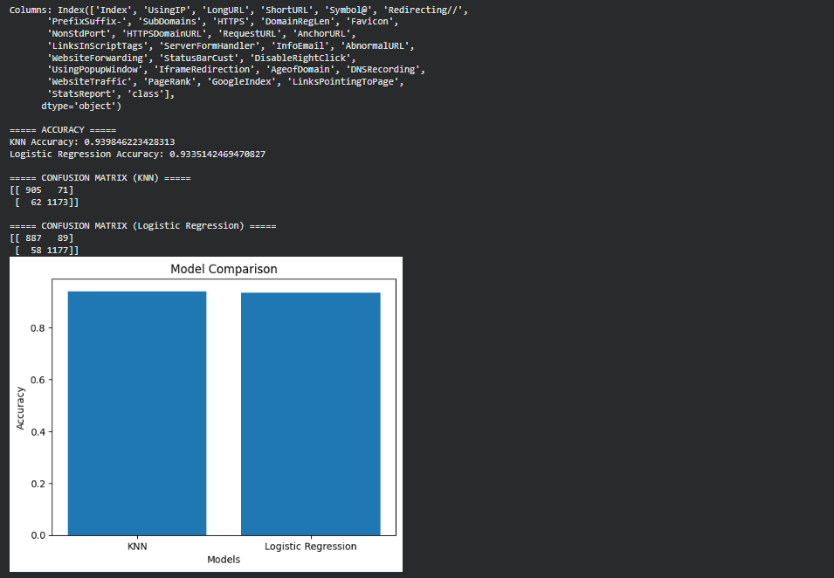

Fig. 1. Model Comparison Graph
The results are comparable to the research paper, where the hybrid KNN-SVM model achieved approximately 90% accuracy. This shows that machine learning models are highly effective in phishing detection.

5. CONCLUSION
This paper demonstrates the effectiveness of machine learning techniques in detecting phishing websites. The study is based on an existing hybrid model and extended using KNN and Logistic Regression.
The results show that KNN achieves higher accuracy compared to Logistic Regression and performs effectively in phishing detection tasks. Machine learning-based approaches can significantly improve cybersecurity systems by automatically identifying malicious websites.
Future work can include implementing deep learning models and real-time phishing detection systems.

REFERENCES (
[1] Altyeb Altaher, “Phishing Websites Classification using Hybrid SVM and KNN Approach”, International Journal of Advanced Computer Science and Applications (IJACSA), 2017.

